Crossing the Line AP Human Geography 9
Module 5, Lesson 1 ARC GIS online
Boundaries are invisible lines on Earth’s surface. They divide the surface area into distinct political entities. In this activity, you will use GIS to investigate different types of international boundaries, explore the implications of various boundary configurations, and observe boundary changes that occurred in recent years.

Task 1: Open the map

- Go to this link:
http://goo.gl/QNjkwq
http://www.arcgis.com/home/webmap/viewer.html?webmap=38bd2ee61fef42e3b22b1aecc33800cc

- The map document opens, and you see a satellite image of the world like below.

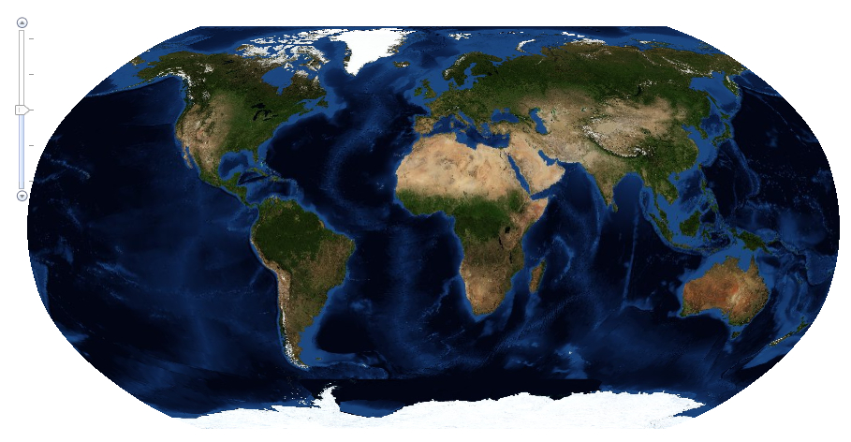

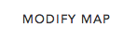

- Click on the Modify Map button on the top right corner above your map.

- Click on the middle icon under ‘Details’ in the top left corner of the screen. Hovering over it you will see “Show Contents of Map.” Check the box that says world imagery. No other boxes should be checked.
  - You should now be able to see all the map layers available to view with a check mark next to the layer name.

- Click on Basemap in the top left corner and choose the imagery map in the first row by clicking on it.

Task 2: Explore mountain ranges as physiographic boundaries

As astronaut Russell L. Schweickart said, “If you could view the world from space, you would see no boundary lines. Boundaries are human-made lines that define the world’s political entities.”

There are several types of boundaries between countries. For example, physiographic boundaries follow landscape features such as mountain ranges or rivers.

- Pan the map until Europe is centered on the map. You should be able to zoom in and out to see the physical features in greater detail.

Locate Europe’s mountain ranges in the satellite image. Notice that ranges such as the
Pyrenees Mountains in northeastern Spain form a natural boundary. You will use the Create Editable Layer tool to draw a line where you see a mountain range forming a natural boundary between different parts of the continent.
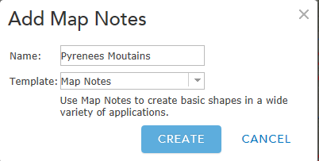
- Click on the Add button (top left) and Add Map Notes.

- Change the title of new layer to Pyrenees Mountains.

- Click on the Create button.
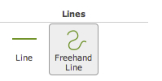
- Click on Freehand Line in the Add Features box to the left of the map.

Now you are ready to draw a physiographic boundary in Europe.

- Click the westernmost edge of the Pyrenees Mountains to start your line. While continuously pressing your left mouse button, continue moving along the path of the mountain range until you reach its easternmost edge (you will see a red line as you are moving your mouse). Let go of your mouse button to complete the line.

- A light green line is displayed in the map and a Lines window will pop up. Accept the title and the symbol color by clicking on the Close button. The Lines window will disappear and you will see the line you drew.

- Click the Details button in the top left of your screen to exit the Add Map Notes window.

- Turn on the Country Boundaries 2007 layer. You see that your line corresponds to a border between two countries.

- Click the country that borders the Pyrenees Mountains to the north.

A popup window shows the layer name and the country name. You can also see all the attributes for that country that are in the attribute table.

From this point on, answers to questions in this activity should be recorded on the answer sheet!

- Q1: The Pyrenees Mountains are the border between which two countries?

- Uncheck the Pyrenees Mountains layer to turn off the boundary line you previously drew.

- Pan to other Western European countries where physiographic boundaries created by mountains correspond to actual political boundaries. Click a country to see its information in the Identify window.

- Q2: Complete the table on the answer sheet. Consult an atlas to learn the names of mountain ranges you don’t know.

Task 3: Explore bodies of water as physiographic boundaries

- Turn off the World Imagery layer and turn on the Rivers, Lakes, and Country Boundaries 2007 layers.

Wherever countries have physiographic boundaries based on rivers, the red boundary line disappears beneath the blue river on the map. Look closely at Europe to see if you can find any boundaries that are rivers.

- Click a country that has a river as part of a boundary (you may want to zoom or pan the map). Click on the country to identify it.

- Q3: In the table on the answer sheet, record the names of three pairs of countries that share a boundary that’s a river (to identify the names of the rivers, click on the rivers on the map to view its information in the popup window).

Coastlines are also physiographic boundaries. Countries that do not have a coastline are said to be landlocked.

- Zoom or pan so that Western Europe is in your full view.

- Q4: Name three landlocked countries in Western Europe. Use the Identify tool if you don’t know the name of a specific country (remember to have Country Boundaries 2007 turned on)
Task 4: Explore geometric boundaries

Another type of boundary is a geometric boundary. Geometric boundaries consist of straight lines that do not correspond to physical features on the earth’s surface.

- Zoom and pan so you can see the entire map in the map view.

- Pan so that Africa is in the middle and then zoom in on Africa.

You see many rivers that overlap boundaries throughout the African continent.

- Look at the map and locate countries with a shared geometric boundary. See definition above. Where don’t you see geometric boundaries?

- Click on the countries to view the information about those countries.

- Q5: List three pairs of countries with a shared geometric boundary.

Task 5: Explore anthropographic boundaries based on language and religion

A third type of boundary is anthropographic. Anthropographic boundaries are based on societal characteristics such as language, religion, or ethnicity.

- Turn off Rivers, Lakes, and Country Boundaries 2007.

- Turn on the Languages layer.

- Hover on the word Languages, click on the blue dotted line to the right, and click on move down. Continue moving the Language layer down until it is below the Country Boundaries 2007 layer.

- Click on the word Languages (shows as a blue link) to expand the legend. The distribution of major language groups in the world is displayed.

- Pan out and observe the boundaries based on language.

- Q6: Click on the color on the map representing the principal language family in South America and Western Europe. Write these on your answer sheet.

- Turn on Country Boundaries 2007 layer.
- Q7: Pan and zoom to locate countries separated by an anthropographic boundary based on language. List three pairs of such countries on the answer sheet.

- Zoom out until you can see all countries displayed on the map. Turn off the Country Boundaries 2007 and Language layers. Click on the word Languages to collapse the legend.

- Turn on the Religion layer by placing a check in the box to the left of the word Religions.

- Hover on the word Religions, click on the blue dotted line to the right, and click on move down. Continue moving the Religion layer down until it is below the Country Boundaries 2007 layer.

- Click on the Religions layer (shows as a blue link) to expand the legend. The distribution of major religion groups in the world is displayed.

- Observe the boundaries based on religion throughout the world.

- Q8: Use the Identify and Zoom tools to determine the principal religions in North America and Africa. Record them on the answer sheet.

- Turn on Country Boundaries 2007

- Q9: Pan and zoom to locate countries separated by an anthropographic boundary based on religion. List three pairs of such countries on the answer sheet.

Task 6: Review physiographic, geometric, and anthropographic boundaries

- Q10: List additional examples of countries separated by physiographic, geometric, or anthropographic boundaries for each continent in the table on the answer sheet. CHOOSE at least 5

Task 7: Explore the effects of boundary shape, cultural diversity, and access to natural resources
Boundaries define a country’s size and shape, or territorial morphology, which may be related to the cohesiveness of that country (how united it is). Small compact nations or ones that are circular or hexagonal, for example, are likely to be more united than ones that are elongated or fragmented.

- Close the popup window it it’s still open.

- Zoom back to see the whole world again. Turn off all layers except for Country Boundaries 2007 and collapse the Religions legend in the Contents.
- In the Find dialog box type Chile and click the search icon.

- Q11: The table on the answer sheet illustrates six types of countries based on shape and gives an example of each. Chile is listed as an example of an elongated country. Use the Find, Zoom, and Pan tools to locate another example of each type of country. Record the countries in the Example 2 column. Remember, you can use the Identify tool to find the names of countries that you do not know.

Another factor that influences cohesiveness is cultural diversity.

- Zoom out until you see the entire world. Turn on Country Boundaries 2007 if it is turned off and Languages. You will probably need to adjust the transparency. To do that, click the 3 blue dots (more options) to the right of the layer and click transparency.

- Q12: Identify three culturally uniform countries on the basis of language family.

- Q13: Identify three culturally diverse countries on the basis of language family.
L1
Boundaries also influence economic activities. Earlier in this activity, you identified landlocked countries in Western Europe. Historically, these countries were limited in their ability to trade directly with other nations because imports and exports had to pass through other countries en route to their destination.

- Zoom out until you see the entire world. Turn off Languages and turn on Lakes.

- Q14 Record an example of a landlocked country for each continent listed in the table on the answer sheet. For a continent that does not have a landlocked country, write “None.”

- Close the Find dialog box if it is still open.

Boundaries also influence a country’s economic activities dependent on access to natural resources.

- Zoom out until you see the entire world. Turn on the Oil and Gas layer.

- Use the Zoom In tool to focus on Southeast Asia.

- Q15: Name two Southeast Asian countries that do not have any (or have very little) oil and gas resources within their land borders (pan, zoom and click on countries to obtain information).

- Q16: Name two Southeast Asian countries that have a lot of oil and gas resources within their land borders.

- Turn off the Oil and Gas layer.

- Zoom out until you see the entire world. Turn on the World Imagery layer.
Task 8: Explore boundary changes that occurred in the 1990s

Political boundaries can change in many ways. A large country may split into smaller ones, small countries may combine to form a larger one, and territories that were once part of one country may be incorporated into another.

- Turn on the Country Boundaries 1992 layer and the Country Boundaries 2007 layer.

- The international boundaries from 1992 are displayed as yellow lines.

- Because the 1992 boundaries cover the 2007 boundaries on the map, the only 2007 boundary lines (red) that are visible are those that did not exist in 1992.

- Q17: Describe three political-boundary changes between 1992 and 2007 (use the Zoom and Pan tools to get a closer look, and the Identify tool to identify countries).

- Q18: Name two countries that existed in 1992 but do not exist in 2007.

In this exercise, you used ArcGIS online to explore the various types of political boundaries and their impact on the countries they define. You added layers and used the Find, Identify, Zoom, and Pan tools to investigate the maps. You observed and analyzed boundary changes between 1992 and 2007.

Nice work! Happy New Year!

If you finish with time to spare, check out these links!
- Cool pictures of international borders - http://goo.gl/So81FR
- “China building ‘great wall of sand’ in South China Sea” (BBC News) - http://goo.gl/BYc9do

